Grizzly Bagers

Internal Meeting

4 October 2016

**In-Attendance**

|  |  |
| --- | --- |
| Christopher Teo | Project Manager |
| Yu Zheng Yuan | Business Analyst, Back-End Developer |
| Aloysius Lam | Front-End Developer |
| Shahid Bin Abdul Rahmat | Lead Front-End Developer |
| Friedemann Ang | Lead Back-End Developer |
| Jason Wu | Back-End Developer |

The meeting commenced at 1403h at SMU School of Information Systems Seminar Room 3-3. The following points were discussed,

|  |  |  |  |  |
| --- | --- | --- | --- | --- |
| **S/N** | **Item** | **Assignee** | **Status** | **Due Date** |
| 1 | As-Is Process: Visitor signs in to the hospital  To-Be Process 1: Visitor Signs in & signs out  To-be Process 2: Visitor Signs in, checks in at subsequent checkpoints within the hospital & then signs out  To-be Process 3: Visitor signs in & is tracked periodically until he/she signs out | - | - | - |
| 2 | The agreement among members was   * Not to make the job of nurses any more tedious * To ensure that visitors do not feel restricted while going through any of the suggested To-Be Processes | - | - | - |
| 3 | Schedule a Meeting with Client on 6 or 7 October to get their inputs on the proposed to-be processes discussed during the Meeting | Christopher | To-do | 5 October 2016 |
| 4 | Create Lesson Plan for .NET Programming Language & Frameworks | Shahid | To-do | 9 October 2016 |
| 5 | Map out Business Process Flow for the As-Is & 3 proposed To-Be processes | Zheng Yuan & Jason | To-do | 6 October 2016 |
| 6 | Explore IOT & Networking Solutions for the project. Come out with a list of useful equipment & their cost based on the intermediate level to-be process | Aloysius & Friedemann | To-do | 6 October 2016 |

The Project Manager Concluded the meeting at 1709h. The minutes will be vetted & circulated to the relevant parties within 24h of the meeting.

Recorded by,

*Aloysius Lam*

*Front-End Developer*

*Grizzly Bagers*

Vetted by,

*Christopher Teo*

*Project Manager*

*Grizzly Bagers*

Attachments

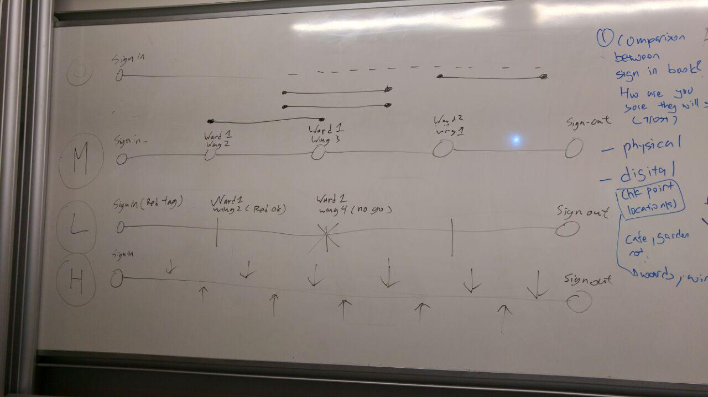

As-Is, To-Be Visitor Tracking Processes

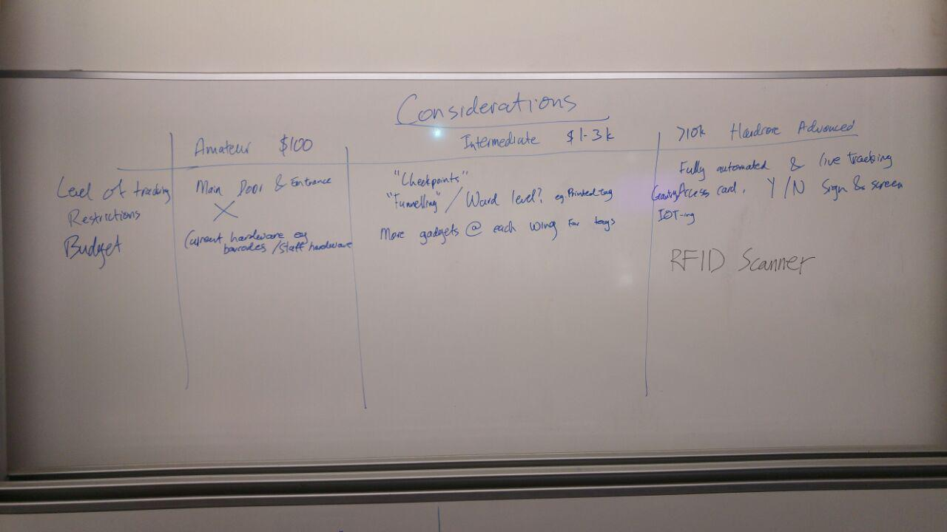

Project Considerations